TASK 1:

CODE:

package day5;

import org.openqa.selenium.By;

import org.openqa.selenium.WebDriver;

import org.openqa.selenium.WebElement;

import org.openqa.selenium.edge.EdgeDriver;

import org.openqa.selenium.edge.EdgeOptions;

import org.openqa.selenium.interactions.Actions;

import io.github.bonigarcia.wdm.WebDriverManager;

public class Task1 {

public static void main(String[] args) {

WebDriverManager.edgedriver().setup();

EdgeOptions com = new EdgeOptions();

com.addArguments("--remote-allow-origins=*");

WebDriver driver = new EdgeDriver(com);

driver.manage().window().maximize();

driver.get("https://demoqa.com/droppable/");

Actions a = new Actions(driver);

WebElement source = driver.findElement(By.xpath("//*[@id=\'draggable\']"));

WebElement destination = driver.findElement(By.xpath("//*[@id=\'droppable\']"));

a.dragAndDrop(source,destination).build().perform();

}

}

OUTPUT :

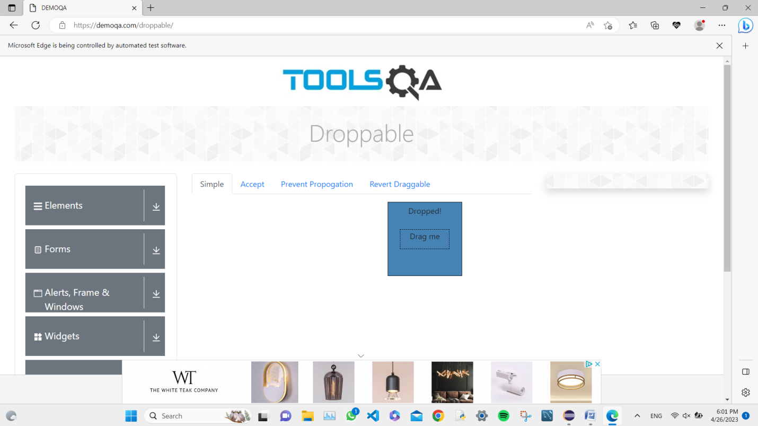

TASK 2:

CODE:

package day5;

import org.openqa.selenium.By;

import org.openqa.selenium.WebDriver;

import org.openqa.selenium.WebElement;

import org.openqa.selenium.edge.EdgeDriver;

import org.openqa.selenium.edge.EdgeOptions;

import org.openqa.selenium.interactions.Actions;

import io.github.bonigarcia.wdm.WebDriverManager;

public class Task2 {

public static void main(String[] args) throws InterruptedException {

WebDriverManager.edgedriver().setup();

EdgeOptions com = new EdgeOptions();

com.addArguments("--remote-allow-origins=*");

WebDriver driver = new EdgeDriver(com);

driver.manage().window().maximize();

driver.get("https://jqueryui.com/droppable/");

driver.switchTo().frame(0);

WebElement x =driver.findElement(By.id("draggable"));

WebElement y =driver.findElement(By.id("droppable"));

Actions a = new Actions(driver);

a.dragAndDrop(x, y).build().perform();

}

}

OUTPUT:

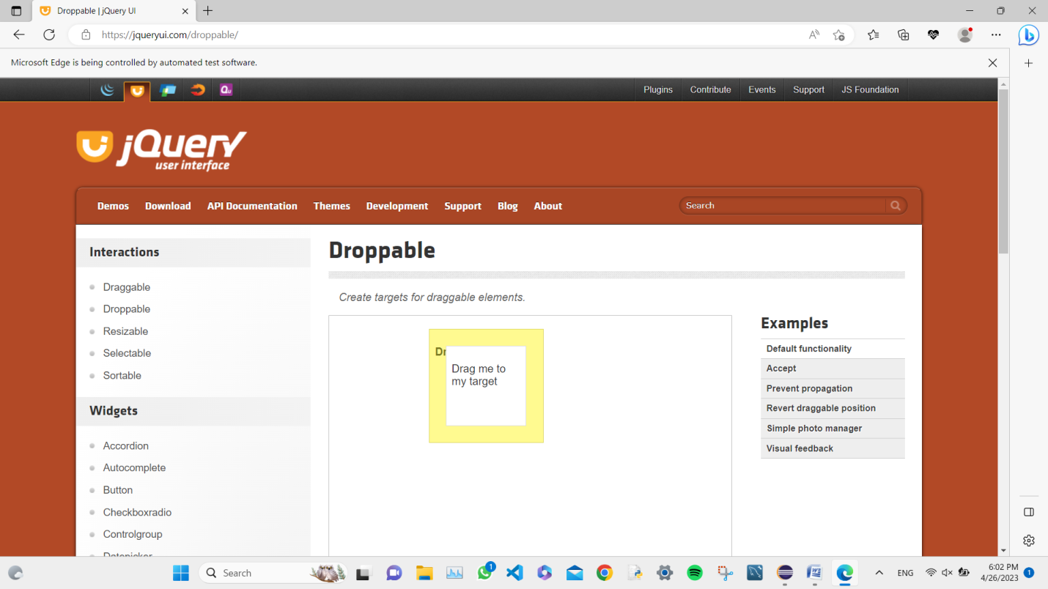

TASK 3:

CODE:

package day5;

import org.openqa.selenium.By;

import org.openqa.selenium.WebDriver;

import org.openqa.selenium.WebElement;

import org.openqa.selenium.edge.EdgeDriver;

import org.openqa.selenium.edge.EdgeOptions;

import org.openqa.selenium.interactions.Actions;

import io.github.bonigarcia.wdm.WebDriverManager;

public class Task3 {

public static void main(String[] args) throws InterruptedException {

WebDriverManager.edgedriver().setup();

EdgeOptions com = new EdgeOptions();

com.addArguments("--remote-allow-origins=*");

WebDriver driver = new EdgeDriver(com);

driver.manage().window().maximize();

driver.get("https://demo.guru99.com/test/delete_customer.php");

driver.findElement(By.xpath("/html/body/form/table/tbody/tr[2]/td[2]/input")).sendKeys("401");

Thread.sleep(700);

driver.findElement(By.xpath("/html/body/form/table/tbody/tr[3]/td[2]/input[1]")).click();

driver.switchTo().alert().dismiss();

Thread.sleep(700);

driver.findElement(By.xpath("/html/body/form/table/tbody/tr[2]/td[2]/input")).clear();

Thread.sleep(700);

driver.findElement(By.xpath("/html/body/form/table/tbody/tr[2]/td[2]/input")).sendKeys("402");

driver.findElement(By.xpath("/html/body/form/table/tbody/tr[3]/td[2]/input[1]")).click();

Thread.sleep(700);

driver.switchTo().alert().accept();

String x = driver.switchTo().alert().getText();

System.out.println(x);

}

}

OUTPUT:

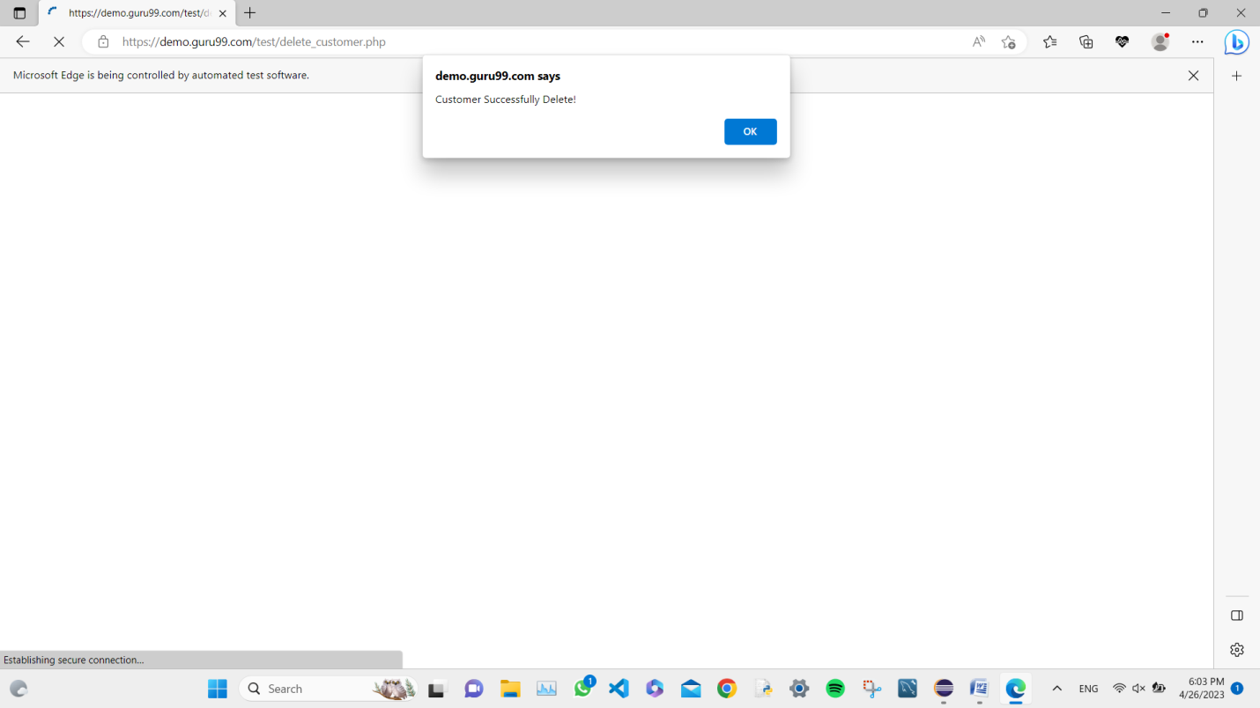

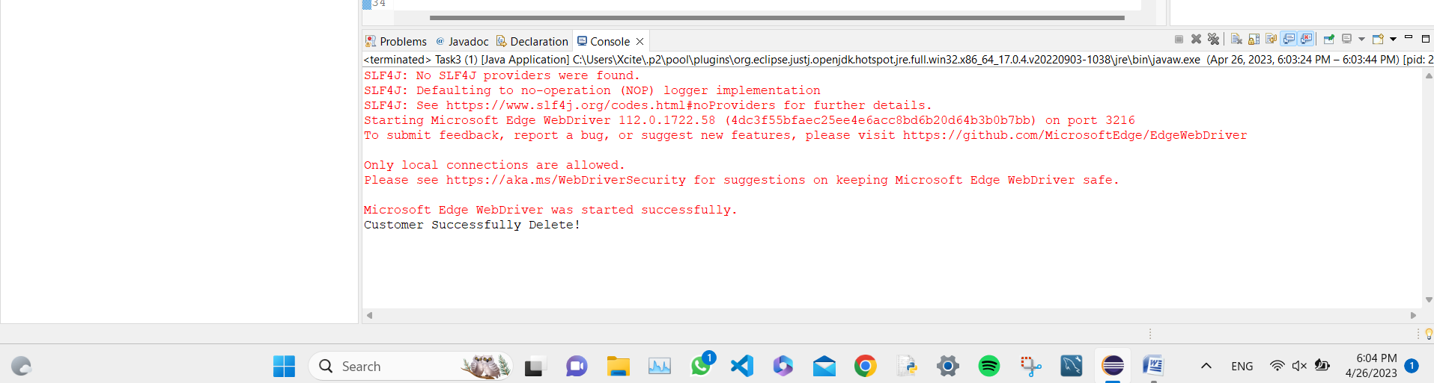

TASK 4:

CODE:

package day5;

import org.openqa.selenium.By;

import org.openqa.selenium.Keys;

import org.openqa.selenium.WebDriver;

import org.openqa.selenium.edge.EdgeDriver;

import org.openqa.selenium.edge.EdgeOptions;

import io.github.bonigarcia.wdm.WebDriverManager;

public class Task4 {

public static void main(String[] args) throws InterruptedException {

WebDriverManager.edgedriver().setup();

EdgeOptions com = new EdgeOptions();

com.addArguments("--remote-allow-origins=*");

WebDriver driver = new EdgeDriver(com);

driver.manage().window().maximize();

driver.get("https://www.abhibus.com/bus-ticket-booking");

Thread.sleep(500);

driver.findElement(By.id("datepicker1")).click();

driver.findElement(By.xpath("//*[@id=\"ui-datepicker-div\"]/div[2]/table/tbody/tr[3]/td[6]/a")).click();

Thread.sleep(500);

driver.findElement(By.id("source")).sendKeys("Coimbatore");

Thread.sleep(500);

driver.findElement(By.id("source")).sendKeys(Keys.ENTER);

driver.findElement(By.id("destination")).sendKeys("Mangalore",Keys.ENTER);

Thread.sleep(500);

driver.findElement(By.id("destination")).sendKeys(Keys.ENTER);

Thread.sleep(500);

driver.findElement(By.id("seo_search_btn")).click();

}

}

OUTPUT:

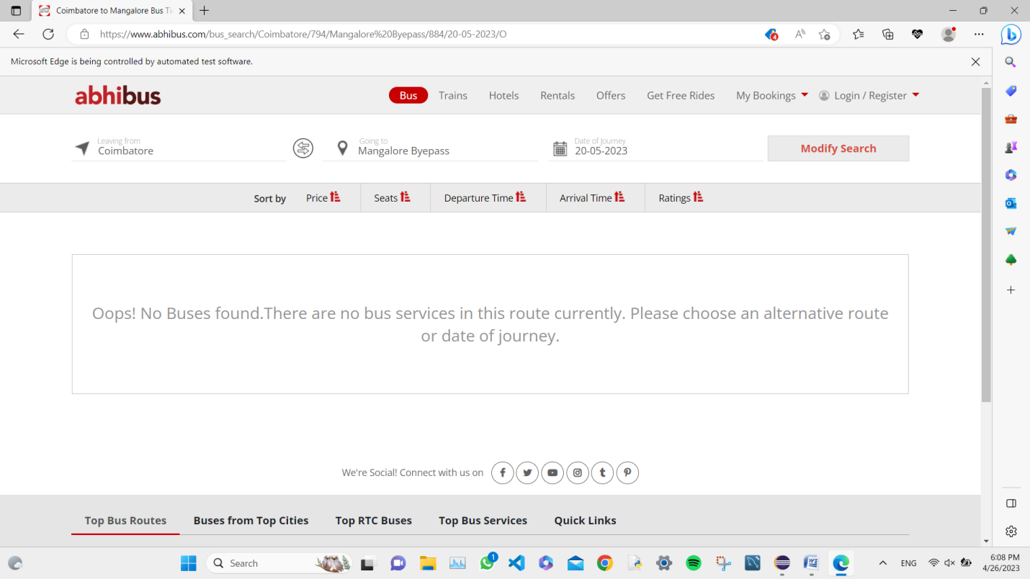

TASK 5:

CODE:

package day5;

import java.net.MalformedURLException;

import org.openqa.selenium.By;

import org.openqa.selenium.Keys;

import org.openqa.selenium.WebDriver;

import org.openqa.selenium.WindowType;

import org.openqa.selenium.chrome.ChromeDriver;

import org.openqa.selenium.edge.EdgeDriver;

import org.openqa.selenium.edge.*;

import org.openqa.selenium.firefox.*;

import org.openqa.selenium.chromium.*;

import org.openqa.selenium.chrome.*;

import io.github.bonigarcia.wdm.WebDriverManager;

public class Task5 {

public static void main(String[] args) throws InterruptedException{

WebDriverManager.edgedriver().setup();

EdgeOptions com = new EdgeOptions();

com.addArguments("--remote-allow-origins=*");

WebDriver driver = new EdgeDriver(com);

driver.manage().window().maximize();

driver.get("https://www.google.com");

driver.findElement(By.name("q")).sendKeys("Apple",Keys.ENTER);

String x1 = driver.getWindowHandle();

String x2 = driver.getTitle();

System.out.println(x1+" "+x2);

driver.switchTo().newWindow(WindowType.WINDOW);

driver.get("https://www.google.com");

driver.findElement(By.name("q")).sendKeys("Selenium",Keys.ENTER);

String y1 = driver.getWindowHandle();

String y2 = driver.getTitle();

System.out.println(y1+" "+y2);

driver.switchTo().newWindow(WindowType.WINDOW);

driver.get("https://www.google.com");

driver.findElement(By.name("q")).sendKeys("Cucumber",Keys.ENTER);

String z1 = driver.getWindowHandle();

String z2 = driver.getTitle();

System.out.println(z1+" "+z2);

}

}

OUTPUT:

